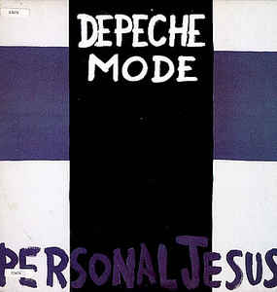
Personal Jesus - Johnny Cash

1989 – 130 BPM – Strum Bas bas haut haut bas
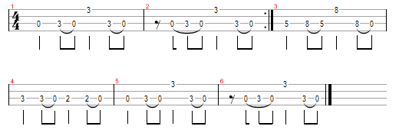

D Fm / D# Cm %
Reach out and touch faith
Cm
Riff (Cm % % %)

Cm % % %
Your own personal jesus
Cm %
Someone to hear your prayers
Fm D# / D7
Fm
Someone who cares

Cm % % %
Your own personal jesus
Cm %
Someone to hear your prayers
Fm D# / D7
D#
Someone whos there

Cm
Feeling unknown
Cm
And you’re all alone
Fm
D7
Flesh and bone
D#
By the telephone
Fm
Lift up the receiver
D# / D7 Cm %
I’ll make you a believer

Cm
Take second best
Cm
Put me to the test
Fm
Things on your chest
D#
You need to confess
V2
Fm
I will deliver
D# / D7 Cm %
You know I’m a forgiver

D Fm / D# Cm %
Reach out and touch faith (2x)

Cm % % %
Your own personal jesus
Cm %
Someone to hear your prayers
Fm D# / D7
Someone who cares

Cm % % %
Your own personal jesus
Cm %
Someone to hear your prayers
Fm D# / D7
Someone whos there

Cm
Feeling unknown
Cm
And you’re all alone
Fm
Flesh and bone
D#
By the telephone
Fm
Lift up the receiver
D# / D7 Cm %
I’ll make you a believer

Fm
I will deliver
D# / D7 Cm %

You know I’m a forgiver

D Fm / D# Cm %
Reach out and touch faith (4x)

